
Name: ____________________________________________________
1. Go to www.studyisland.com
2. Click on  in the top right corner.
3. Click under 
4. Username: na and your student ID number: na123456 Password: tigers
5. Click 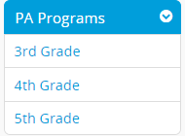on the left of your screen. Be sure to select “5th Grade”.
6. Click or under “Select a Subject”.
7. Click “Lesson” next to the assigned topic such as . Read through each step of the lesson before completing the assignment below.
8. To access the assignment, click “My Class” on the left of your screen. 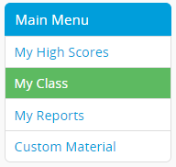
9. Click or
10. Click the assigned topic.
11. Select an answer for each question. When you are ready to move to the next question, click .
12. When you are finished with all of the questions, click .
13. If you need to stop at any time, be sure to click  before you exit the screen.
14. If completing a reading comprehension assignment, record your QAR strategies on the document that follows.
Right There = R.T.
Think and Search T.S.
Author and You = A.Y.
On Your Own= O.O.

1. _____________________

2. _____________________

3. _____________________

4. _____________________

5. _____________________

6. _____________________

7. _____________________

8. _____________________

9. _____________________

10. _____________________

